Overview
Logging serves two competing purposes that must be carefully balanced. On one hand, CERT-In Directions 2022 mandates that Eartigo retain logs for a minimum of 180 days to support incident investigation and reporting. On the other hand, the DPDP Act 2023 and SPDI Rules 2011 require that personal and sensitive data be protected — and a log file is a database like any other. A logging system that captures Aadhaar numbers, bank details, or session tokens in plain text does not improve security; it creates a second, often less-protected copy of the platform's most sensitive data.
The principle for this part is: log enough to detect, investigate, and prove what happened — but never log the sensitive data itself, only the fact that an action occurred.
This part covers:
- What events must be logged and why each one matters
- What must never appear in logs, regardless of purpose
- Log retention, access control, and storage requirements
- Implementation code for structured logging with automatic PII redaction

What Should Be Logged
The following table lists every event category that must generate a log entry on Eartigo. Each entry should capture: timestamp (NTP-synced), actor (user ID and role), action, target resource (by ID, not by content), outcome (success/failure), and source IP address.
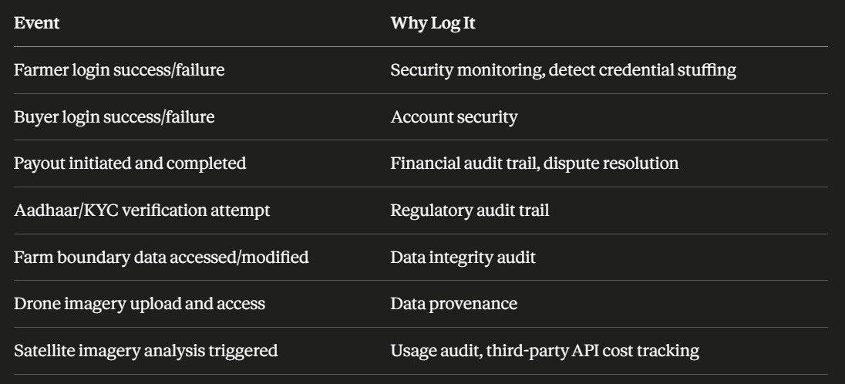
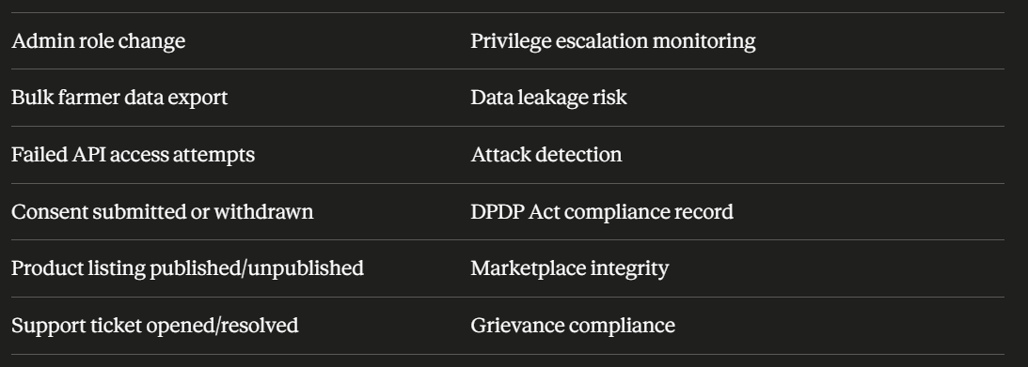

Additional Events Recommended for Eartigo
Beyond the core table above, the following events should also be captured given Eartigo's specific data layers:
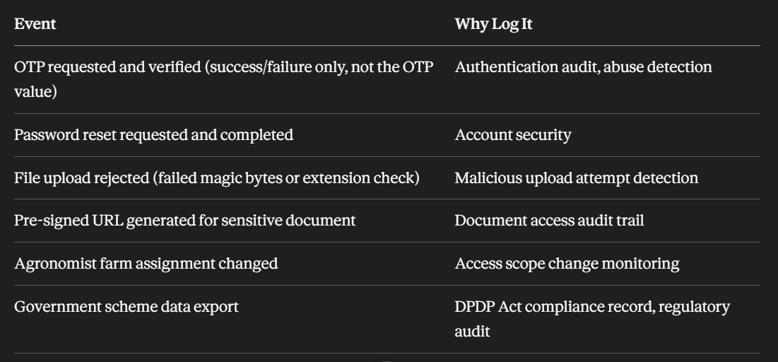
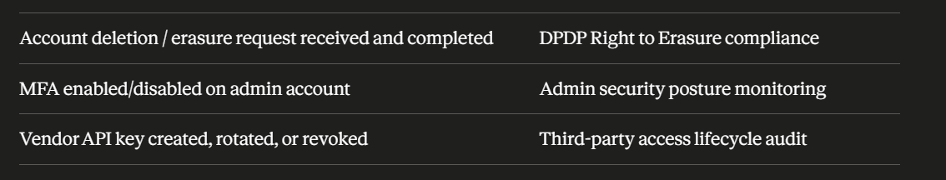

What Must NEVER Be Logged
CERT-In Compliance Note
Under CERT-In Directions 2022, logs must be retained for 180 days. Under SPDI Rules, logs containing sensitive personal data must have access controls. Balance retention requirements with privacy obligations.
The retention requirement above does not mean retaining sensitive data for 180 days — it means retaining the fact that an event occurred for 180 days, with sensitive fields redacted at the point of logging, before the entry is ever written to disk.

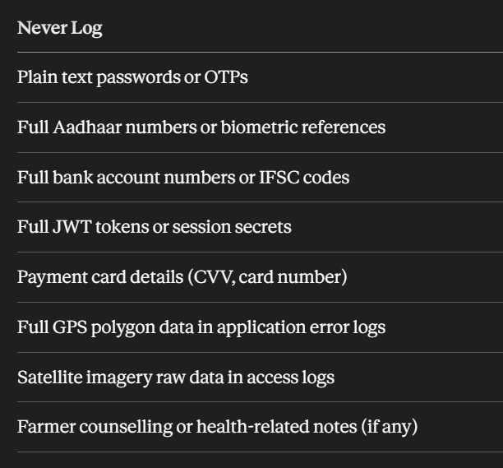

Why Each of These Is Dangerous in Logs
Plain text passwords or OTPs — If a password or OTP is ever logged, it remains recoverable even after the user changes it or the OTP expires, because logs are frequently retained, backed up, and replicated to systems with broader access than the primary database (e.g., centralized logging platforms, third-party log aggregators).
Full Aadhaar numbers or biometric references — This is not just a privacy best practice; it is a potential criminal offence under the Aadhaar Act 2016 if full Aadhaar numbers are stored anywhere outside a UIDAI-authorised system, including in logs.
Full bank account numbers or IFSC codes — Application logs are often accessed by a wider group of engineers (for debugging) than the production database. Logging full financial details multiplies the exposure surface for this SPDI-class data.
Full JWT tokens or session secrets — A logged JWT is a valid, usable credential until it expires. Anyone with read access to logs — including third-party log management tools — effectively has a live session token.
Payment card details (CVV, card number) — Eartigo should never receive these values at all (they should flow directly to the Payment Aggregator), but as a defence-in-depth measure, any accidental capture must never reach a log.
Full GPS polygon data in application error logs — Stack traces and error logs often dump the full request body or object state. A farm boundary polygon appearing in an error log is the same commercially sensitive data described in Part A, now sitting in a less-controlled system.
Satellite imagery raw data in access logs — Logging the actual image bytes or base64-encoded imagery (rather than a reference ID) bloats log storage and duplicates a controlled S3 asset into an uncontrolled location.
Farmer counselling or health-related notes — If Eartigo's support or advisory features ever capture anything resembling health information (e.g., a farmer mentioning a medical reason for a delayed delivery), this becomes sensitive personal data under SPDI Rules and must not be logged in plain text in general application logs.

Log Retention & Access Control

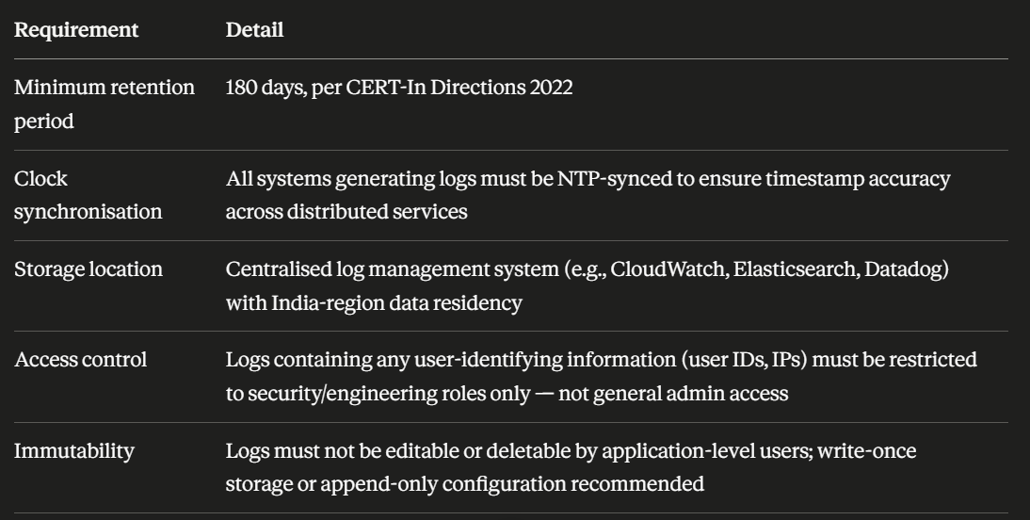
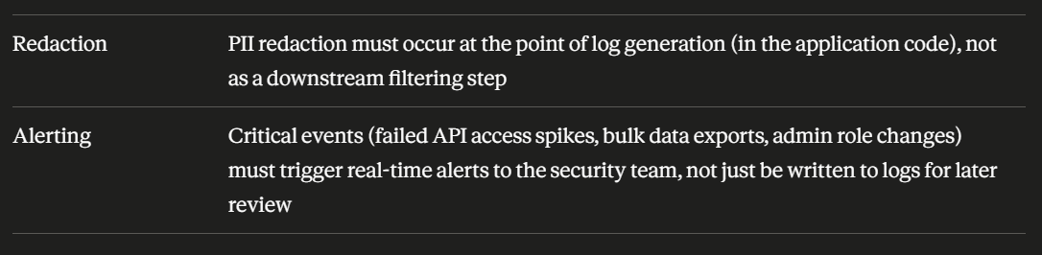

Implementation — Structured Logging with PII Redaction
The following implementation uses Pino, a high-performance structured logger for Node.js, configured with automatic redaction of sensitive fields.

Step 1 — Install Dependencies

npm install pino pino-http

Step 2 — Logger Configuration with Redaction

// config/logger.js
const pino = require('pino');

const logger = pino({
level: process.env.LOG_LEVEL || 'info',
redact: {
paths: [
// Authentication & session
'password',
'password_hash',
'otp',
'otp_hash',
'token',
'access_token',
'refresh_token',
'req.headers.authorization',
'req.headers.cookie',

// Identity & financial
'aadhaar',
'aadhaar_number',
'aadhaar_ref',
'pan',
'pan_ref',
'bank_account',
'account_number',
'ifsc',
'card_number',
'cvv',

// Farm intelligence — sensitive location/imagery data
'gps_coordinates',
'boundary',
'boundary_polygon',
'satellite_image_data',
'drone_image_data',

// Health / counselling notes
'health_notes',
'medical_info',

// Wildcard patterns for nested objects
'*.password',
'*.aadhaar_ref',
'*.bank_account',
'*.gps_coordinates',
],
censor: '[REDACTED]'
},
timestamp: pino.stdTimeFunctions.isoTime,
formatters: {
level: (label) => ({ level: label }),
}
});

module.exports = logger;

Step 3 — HTTP Request Logging Middleware

// middleware/requestLogger.js
const pinoHttp = require('pino-http');
const logger = require('../config/logger');

const httpLogger = pinoHttp({
logger,
customLogLevel: (req, res, err) => {
if (res.statusCode >= 500 || err) return 'error';
if (res.statusCode >= 400) return 'warn';
return 'info';
},
// Don't log full request/response bodies by default — too risky for PII leakage
serializers: {
req: (req) => ({
method: req.method,
url: req.url,
// headers excluded by default; redaction config above covers if added
}),
res: (res) => ({
statusCode: res.statusCode,
}),
},
customSuccessMessage: (req, res) => {
return `${req.method} ${req.url} completed with ${res.statusCode}`;
},
});

module.exports = httpLogger;

Step 4 — Event-Specific Audit Logging
General HTTP request logs are not sufficient for compliance-critical events. The following service writes structured, queryable audit entries for the specific events listed in the "What Should Be Logged" table.
// services/auditLogger.js
const logger = require('../config/logger');
const AuditLog = require('../models/AuditLog'); // from Part C — append-only collection

/**
* Records a compliance-relevant audit event.
* Writes to both the structured application log (for real-time monitoring)
* and the immutable AuditLog collection (for 180-day retention and review).
*/
async function logAuditEvent({ userId, role, action, target, targetId, outcome, req, extra = {} }) {
const entry = {
actor_id: userId,
actor_role: role,
action, // e.g. 'farmer_login', 'payout_completed', 'kyc_verification_attempt'
target, // e.g. 'Farm', 'Payout', 'User'
target_id: targetId,
outcome, // 'success' | 'failure' | 'denied'
ip_address: req?.ip,
user_agent: req?.headers?.['user-agent'],
timestamp: new Date(),
...sanitizeExtra(extra),
};

// Real-time structured log — for dashboards and alerting
logger.info({ audit: entry }, `Audit: ${action} (${outcome})`);

// Immutable audit collection — for CERT-In 180-day retention
await AuditLog.create(entry);
}

// Strip any field that might accidentally contain sensitive data
// before it reaches either log destination
function sanitizeExtra(extra) {
const BLOCKED_KEYS = [
'password', 'otp', 'token', 'aadhaar', 'aadhaar_ref',
'bank_account', 'ifsc', 'card_number', 'cvv',
'gps_coordinates', 'boundary', 'health_notes',
];
const clean = {};
for (const [key, value] of Object.entries(extra)) {
if (BLOCKED_KEYS.some(blocked => key.toLowerCase().includes(blocked))) {
continue; // Drop the field entirely — do not even redact, just omit
}
clean[key] = value;
}
return clean;
}

module.exports = { logAuditEvent };

Step 5 — Usage Examples for Key Events

const { logAuditEvent } = require('../services/auditLogger');

// ── Farmer Login ────────────────────────────────────────────────────────
router.post('/auth/login', async (req, res) => {
const user = await User.findOne({ phone: req.body.phone });
const valid = user && await verifyPassword(req.body.password, user.password_hash);

await logAuditEvent({
userId: user?._id?.toString() || 'unknown',
role: user?.role || 'unknown',
action: 'farmer_login',
target: 'User',
targetId: user?._id?.toString(),
outcome: valid ? 'success' : 'failure',
req,
});

if (!valid) return res.status(401).json({ error: 'Invalid credentials' });
// ... issue tokens
});

// ── Payout Initiated ────────────────────────────────────────────────────
router.post('/payouts/:payoutId/process', authenticate, requireRole('finance_admin'), async (req, res) => {
const payout = await Payout.findById(req.params.payoutId);

await logAuditEvent({
userId: req.user.id,
role: req.user.role,
action: 'payout_initiated',
target: 'Payout',
targetId: payout._id.toString(),
outcome: 'success',
req,
extra: { amount: payout.amount, currency: 'INR' }, // amount is fine; account number is not
});

// ... process payout
});

// ── Aadhaar/KYC Verification Attempt ───────────────────────────────────
router.post('/kyc/verify', authenticate, requireRole('farmer'), async (req, res) => {
const result = await verifyWithKycIntermediary(req.user.id); // never pass full Aadhaar to logger

await logAuditEvent({
userId: req.user.id,
role: req.user.role,
action: 'kyc_verification_attempt',
target: 'User',
targetId: req.user.id,
outcome: result.verified ? 'success' : 'failure',
req,
extra: { intermediary: result.intermediaryName }, // safe metadata only
});

res.json({ verified: result.verified });
});

// ── Farm Boundary Accessed ─────────────────────────────────────────────
router.get('/farms/:farmId/boundary', authenticate, requireRole('farmer'), ownFarmOnly, async (req, res) => {
const farm = await Farm.findById(req.params.farmId);

await logAuditEvent({
userId: req.user.id,
role: req.user.role,
action: 'farm_boundary_accessed',
target: 'Farm',
targetId: req.params.farmId,
outcome: 'success',
req,
// Note: the boundary coordinates themselves are NEVER included here
});

res.json({ boundary: farm.boundary });
});

// ── Bulk Farmer Data Export ────────────────────────────────────────────
router.post('/admin/export/farmers', authenticate, requireRole('super_admin'), async (req, res) => {
const records = await Farmer.find(req.body.filter);

await logAuditEvent({
userId: req.user.id,
role: req.user.role,
action: 'bulk_farmer_data_export',
target: 'Farmer',
targetId: 'bulk',
outcome: 'success',
req,
extra: {
record_count: records.length,
filter_summary: JSON.stringify(req.body.filter), // log the QUERY, not the data
},
});

// ... generate export file
});

// ── Consent Submitted or Withdrawn ─────────────────────────────────────
async function recordConsent(req, consentDetails) {
await ConsentLog.create({ /* ... from Part E ... */ });

await logAuditEvent({
userId: req.user.id,
role: req.user.role,
action: consentDetails.consented ? 'consent_submitted' : 'consent_withdrawn',
target: 'ConsentLog',
targetId: req.user.id,
outcome: 'success',
req,
extra: { form: consentDetails.form, purpose: consentDetails.purpose },
});
}

// ── Admin Role Change ───────────────────────────────────────────────────
router.patch('/admin/users/:userId/role', authenticate, requireRole('super_admin'), async (req, res) => {
const targetUser = await User.findById(req.params.userId);
const oldRole = targetUser.role;
targetUser.role = req.body.newRole;
await targetUser.save();

await logAuditEvent({
userId: req.user.id,
role: req.user.role,
action: 'admin_role_change',
target: 'User',
targetId: req.params.userId,
outcome: 'success',
req,
extra: { old_role: oldRole, new_role: req.body.newRole },
});

res.json({ success: true });
});

// ── Failed API Access Attempt ───────────────────────────────────────────
// Hook this into the global 401/403 error handler
function logAccessFailure(req, res, reason) {
logAuditEvent({
userId: req.user?.id || 'unauthenticated',
role: req.user?.role || 'none',
action: 'failed_api_access',
target: req.path,
targetId: req.params?.id || null,
outcome: 'denied',
req,
extra: { reason, status_code: res.statusCode },
});
}

Step 6 — Verifying No Sensitive Data Leaks via Error Logs
A common source of accidental PII/SPDI logging is uncaught exceptions that dump the full request object, including request bodies containing GPS coordinates, bank details, or Aadhaar references.
// Global error handler — must use the same redaction-aware logger
app.use((err, req, res, next) => {
logger.error({
error: err.message,
stack: err.stack,
path: req.path,
method: req.method,
// DO NOT include req.body or req.query directly here —
// they may contain bank_account, gps_coordinates, aadhaar_ref, etc.
// The redact config in Step 2 covers known field names, but
// defence-in-depth: never pass the raw body to the logger at all.
}, 'Unhandled error');

res.status(err.status || 500).json({ error: 'An error occurred. Please try again.' });
});

Real-Time Alerting Rules
Logging alone is reactive. The following events must trigger real-time alerts to the security team (via Slack, PagerDuty, or equivalent) in addition to being written to logs.
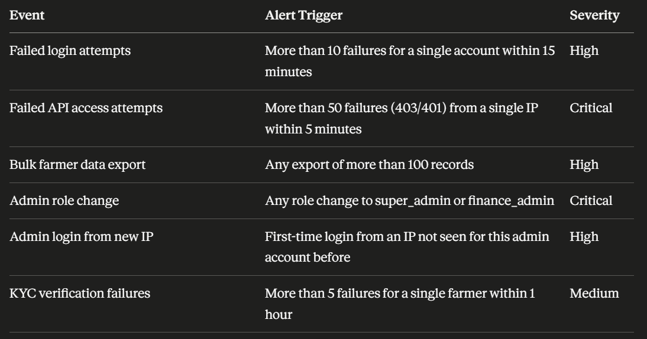
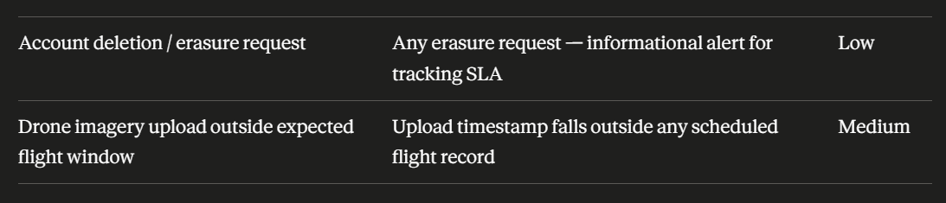

Part H Implementation Checklist

